Walden today announced its policy for providing meals for children served under the National School Lunch, and/or School Breakfast Programs. This school year, healthy meals will be offered at no cost to all students. These meals will be available every school day. Typically, a student’s household must meet income eligibility requirements to qualify for free or reduced-price meals. However, the United States Department of Agriculture (USDA) is allowing schools to waive this requirement for the 2021-2022 school year.
Households will not be required to submit a meal application form to receive meals at no charge this school year. However, Walden is still collecting and processing applications for free and reduced-price meals. This is because school funding and eligibility for other programs depends on completed meal applications. Completing an application this year may also prevent a gap in benefits for your child next year.
Each household will receive a letter informing them of the program, including contact information for any questions. Each school and/or the school nutrition office has a copy of the policy, which may be reviewed by any interested party. It is important to submit a completed meal application as soon as possible.
- Only one meal application is needed for each household. Applications are collected at the local level; each school district or charter school has their own process for submitting applications.
- Applications are available at https://gabriel-west-mjnx.squarespace.com/schoolmealsfaq

Criteria for Free and Reduced-Price Meal Benefits
The following criteria will be used to determine a child’s eligibility for free or reduced-price meal benefits for School Year 2021-2022:
Income
- Household income that is at or below the income eligibility levels
Categorical or Automatic Eligibility
- Household receiving Supplemental Nutrition Assistance Program (SNAP), Temporary Assistance for Needy Families (TANF); or Food Distribution Program on Indian Reservations (FDPIR)
Program Participant
- Child’s status as a foster child, homeless, runaway, migrant, or displaced by a declared disaster
- Child’s enrollment in Head Start or Even Start
Income Eligibility
For those households that qualify for free or reduced-price meals based on income, an adult in the household must complete the free and reduced-price meal application and return it to Kati, office assistant, es.office.manager@waldenschool.us. Those individuals filling out the application will need to provide the following information:
- Names of all household members
- Amount, frequency, and source of current income for each household member
- Last 4 digits of the Social Security number of the adult household member who signs the application or, if the adult does not have a social security number, check the box for “No Social Security number”
- Signature of an adult household member attesting that the information provided is correct
Categorical or Program Eligibility
Walden is working with local agencies to identify all children who are categorically and program eligible. Walden will notify the households of these children that they do not need to complete an application. Any household that does not receive a letter and feels it should have should contact Kati, office assistant, es.office.manager@waldenschool.us.
Determining Eligibility
Under the provisions of the free and reduced-price meal policy, Kati, office assistant, es.office.manager@waldenschool.us will review applications and determine eligibility. Households or guardians dissatisfied with the Reviewing Official’s eligibility determination may wish to discuss the decision with the Reviewing Official on an informal basis. Households wishing to make a formal appeal for a hearing on the decision may make a request either orally or in writing to Lois Bobo, lois@waldenschool.us.
Any household that wishes to decline benefits should contact Kati, office assistant, es.office.manager@waldenschool.us.
Applications may be submitted anytime during the school year. The information households provide on the application will be used to determine eligibility. Applications may also be verified by the school officials at any time during the school year.
Unexpected Circumstances
If a household member becomes unemployed or if the household size increases, the household should contact the school. Such changes may make the children of the household eligible for benefits if the household’s income falls at or below the attached current income eligibility guidelines.
Sharing Information
The information provided by the household is confidential and will be used only for purposes of determining eligibility and verifying data, unless a wavier releasing the use of the information for other specific programs is signed by the parent or guardian. Families who are notified of categorical or automatic eligibility (directly certified) will receive a wavier release form for their signature with the notification letter. The household name and address will be given to the Children’s Health Insurance Program (CHIP) unless “No” is checked on the back of the application.
Supplemental Nutrition Program for Women, Infants & Children (WIC) may be eligible for free or reduced-price meals. Individuals should complete an application for free and reduced-price meals and return it to the school where the child is enrolled. The family will be notified of the child’s eligibility.
Income Eligibility Guidelines
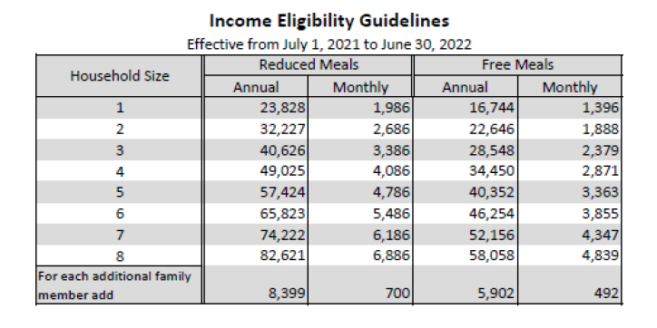
In accordance with Federal civil rights law and U.S. Department of Agriculture (USDA) civil rights regulations and policies, the USDA, its Agencies, offices, and employees, and institutions participating in or administering USDA programs are prohibited from discriminating based on race, color, national origin, sex, disability, age, or reprisal or retaliation for prior civil rights activity in any program or activity conducted or funded by USDA.
Persons with disabilities who require alternative means of communication for program information (e.g. Braille, large print, audiotape, American Sign Language, etc.), should contact the Agency (State or local) where they applied for benefits. Individuals who are deaf, hard of hearing or have speech disabilities may contact USDA through the Federal Relay Service at (800)877-8339. Additionally, program information may be made available in languages otherthan English.
To file a program complaint of discrimination, complete the USDA Program Discrimination Complaint Form, (AD-3027) found online at: https://www.usda.gov/oascr/how-to-file-a-program-discrimination-complaint, and at any USDA office, or write a letter addressed to USDA and provide in the letter all of the information requested in the form. To request a copy of the complaint form, call (866) 632-9992. Submit your completed form or letter to USDA by:
(1) Mail: U.S. Department of Agriculture
Office of the Assistant Secretary for Civil Rights
1400 Independence Avenue, SW
Washington, D.C. 20250-9410;
(2) fax: (202) 690-7442; or
(3) email: program.intake@usda.gov.

This institution is an equal opportunity provider.

